|  |  |
| --- | --- |
| **To:** | John Achilles |
| **From:** | Viliami Fihaki |
| **Date:** | 07/03/2018 |
| **Subject:** | Business Plan for: Computer parts and Repairs (C2Laine Computer Services) |

# Terms of References

# Procedure

# Summary:

Troubleshooting and Repair Computers

# Introduction:

* 1. Rationale and Background
     1. Our Company is a new small business of locally owned and operated IT service.
     2. Our Company always looks for the best technology option that represents the best long-term growth potential for the company.
     3. Our Company determines the most effective cost and technologically solution for our customers.
  2. Business Objective
     1. We are committed to the business principle of incorporating quality services into our daily activities to deliver the best of our ability into any job we do.
     2. Maintain and gain more customers with our commitment to strong execution. Lead with the best ethical standards of work in-order to satisfy our customer’s needs.
  3. Mission Statement
     1. We evolve with the IT Service industry to provide our clients with the best service and product that satisfy all our clients’ Computer requirement.
     2. Our Company aims for competitive and affordable pricing
     3. We dedicate our time for the best quality of Customer Service delivered to our clients with a sense of warmth, friendliness, individual pride within the Company Spirit
  4. Potential Risk
     1. S.W.O.T

|  |  |
| --- | --- |
| Strengths | Weakness |
|  |  |
| Opportunities | Threats |
|  | * Financial Risk is one of the main threat that we are aware of. The possibility of a sudden financial loss is a big risk to the business * Competitor around the Area |

# Company Summary:

* 1. Location: Will be a home base business located at 272 St Andrews Drive, Bethlehem. Tauranga

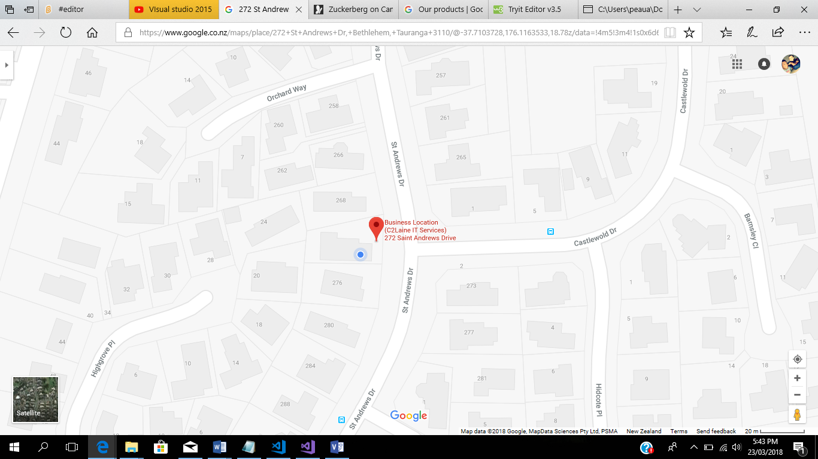

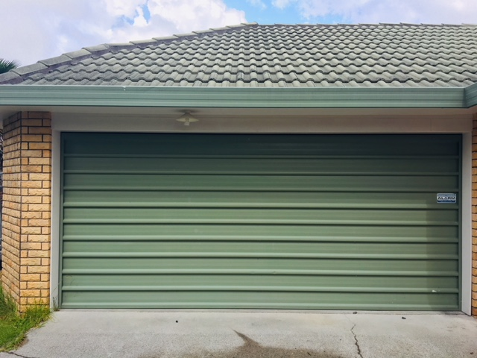

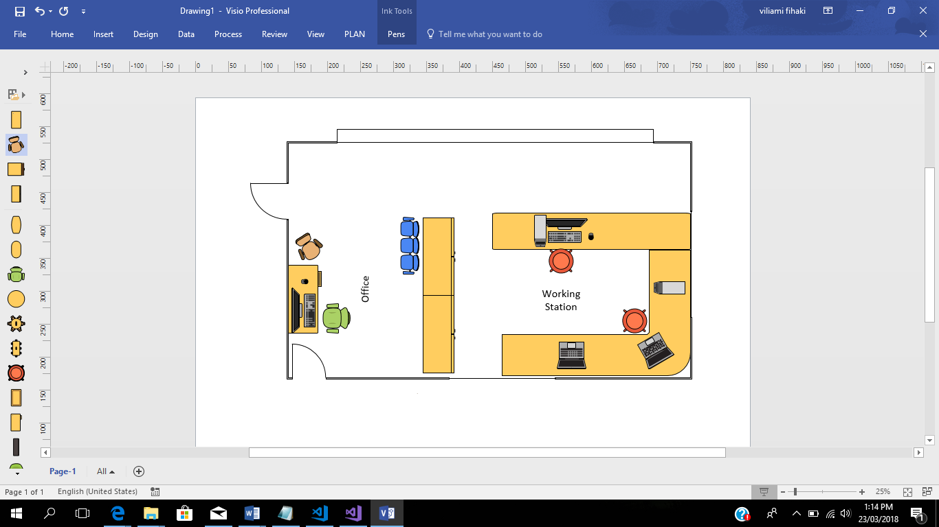

* 1. Services Provided by the Company
     1. Troubleshooting and Repair
        1. We will diagnose and identify the root of the problem on desktops and laptops and come up with the best solution with every repair we do.
     2. Security Services
     3. Data Backup & Recovery
        1. Losing data from your computer is a recurring potential risk that we all could face, for example, a sudden power cut or unintentionally deleting files etc. Our Company can work with you to understand what information is of importance and come up with a strategy that provides you with a backup solution that protects your data daily, and ensures a recovery plan is in place if required.
     4. Remote Support Services
  2. Start-up Cost:

# Market Analysis

* 1. Our services are for anyone that owns a Computer or Laptop
  2. Sponsored Facebook advertising
  3. Flyers distributed locally

# Salary and Wages to Employee

* 1. I will be the only employee, 65% of earnings will be my wages 35% will remain in the business

# Ethical and Legal Consideration to the business

# Our company reserves the right to report any unlawful

# Ongoing maintenance and Security Consideration

# Conclusion